Name: Dustyne Brown
Date: 9/10/12

Objective: After reading Chapter 03, complete the following questions in reference to the database tables in the figure below. This assignment will be available in LIONSLINK under the MYCOURSES tab in the FILES area. You may download it and type your answers into this document or create an additional document with your answers as you wish. Use VISIO to create the ERD’s and copy and paste the drawing into this file (or attach it).
DO NOT HAND DRAW THE ERD’S

Save this document with your changes and e-mail it to me as an attachment to a LIONSLINK e-mail before class Thursday.

BRING PRINT OUTS OF YOUR DOCUMENT AND DRAWING TO CLASS!!

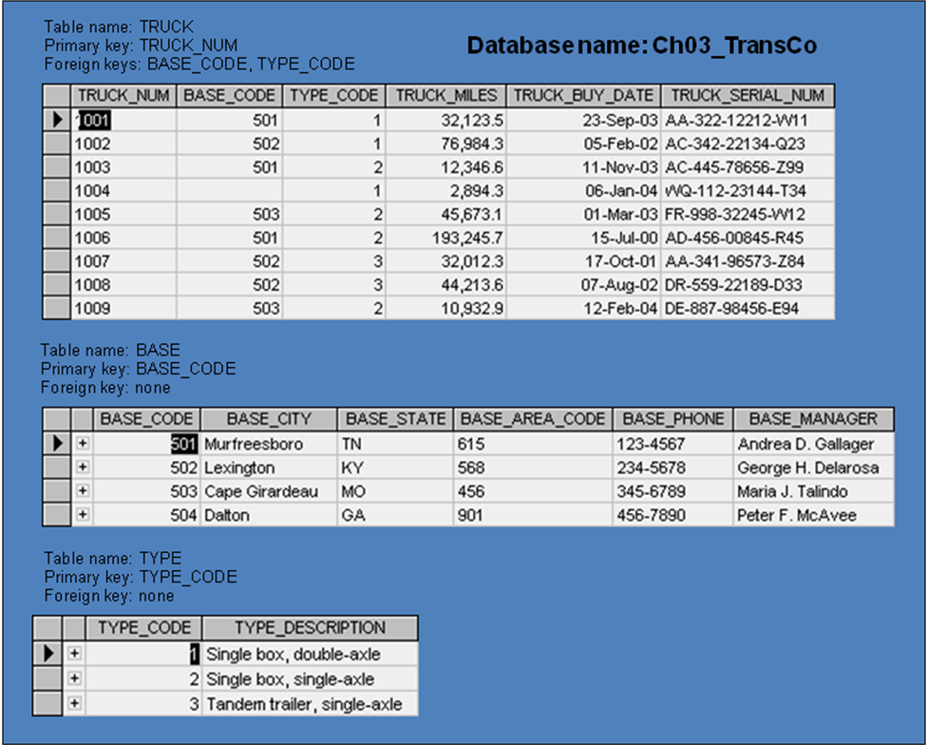
- Write 5 business rules you feel would realistically apply to these tables.

One base code may only relate to once city. (1:1)
Each city may only have one base code. (1:1)
One type code may only relate to one type description. (1:1)
Each type description may only have one type code. (1:1)
Each city may only have one area code. (1:1)
One area code may relate to many cities. (1:M)
Every order must have at least one buy date. (1:1)
One buy date may relate to many orders. (M:1)

- Using the form below, for each table in the database, identify the primary key and the foreign key(s). If a table does not have a foreign key, write “None” in the appropriate space provided.

TABLE | PRIMARY KEY | FOREIGN KEY(S)
TRUCK | TRUCK_NUM | BASE_CODE, TYPE_CODE
BASE | BASE_CODE | NONE
TYPE | TYPE_CODE | NONE

- Write the relationship statements you feel exist among these tables. Be sure to include the relationship TYPE (connectivity) for each. (HINT: remember that foreign keys establish relationships.)

Each base code relates to once city, which is used in the BASE table to list the city, state, area code, phone and Manager’s name.
Each type code is used in the TYPE table to list the TYPE_DESCRIPTION in the table.

- Do the tables exhibit entity integrity? Complete the form below by answering yes or no for each table in the database. In every case, explain your answer!

TABLE | ENTITY INTEGRITY | EXPLANATION
TRUCK | Yes | Information is never repeated about the same order, and every truck number is unique, the only flaw I can easily see in the table is 1 missing base code for truck number 1004
BASE | No | Every city is unique and lists all information, which is good, the flaw with the table is a single question. “What if you have business with multiple people/businesses in a single city?”
TYPE | Yes | This table lists a short description of what each type-code means, and never repeats data, or entries.

- Do the tables exhibit referential integrity? Using the form below, answer yes or no for each table; then explain your answer for each. Write NA (Not Applicable) if the table does not have a foreign key.

TABLE | REFERENTIAL INTEGRITY | EXPLANATION
TRUCK | Yes | Provides the TYPE_CODE and BASE_CODE to be plugged into the other two tables to allow access to more information about the order.
BASE | NA | NA
TYPE | NA | NA

- Identify the TRUCK table’s candidate keys and list them here.
TRUCK_NUM, TRUCK_MILES, TRUCK_SERIAL_NUM, TRUCK_BUY_DATE

- Create the Crowsfoot ERD for this database.
